Criterion F: Feedback from client

1

2

3

4

5

6

7

Question
Are you pleased with the final product?

What are the strengths of the application?

What areas of the application need more development?

How beneficial do you think the application will be to the club?

Was the product completed on time?

Have the specific performance criteria been met?
a) To provide an easy channel of communication for members
b) To reduce the amount of queries towards officers and advisors
c) To improve member involvement

Would you use my services again in the future?

Y/N
Yes

--

--

--

Yes

Yes
Yes
Yes

Yes

Comments
Yes, the final product is exactly what was specified.

The application enables users to see upcoming dates, twitter feeds and contact information. It has more than just a single facet.

The loading of the calendar is a bit slow. It would be nice to improve the speed of the app.

It will be very beneficial. Members of the club can easily have current information at their fingertips.

Yes, the product was completed as scheduled.

Members will be able to communicate through electronic means with leadership team and advisors. Overall, member involvement will be increased.

Definitely. The product is very well done.

Signature
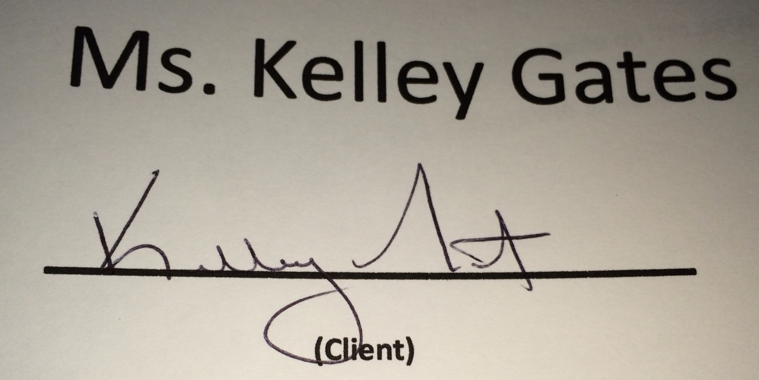
Date: February 25th, 2014

